EXP-4
String Handling Using Raptor
Aim
To design a flowchart using Raptor to display and return the total number of characters present in a given string.
Procedure
1. Open Raptor and create a new flowchart.
2. Design flowchart steps:
• Input a string from the user
• Store the string in a variable
• Find the length of the string
• Display the total number of characters
3. Add flowchart logic:
• Use Input Symbol to accept the string
• Use Assignment Symbol to calculate character count
Example:
count ← Length(str)
• Use Output Symbol to display the count
4. Execute and validate the flowchart using different string inputs.
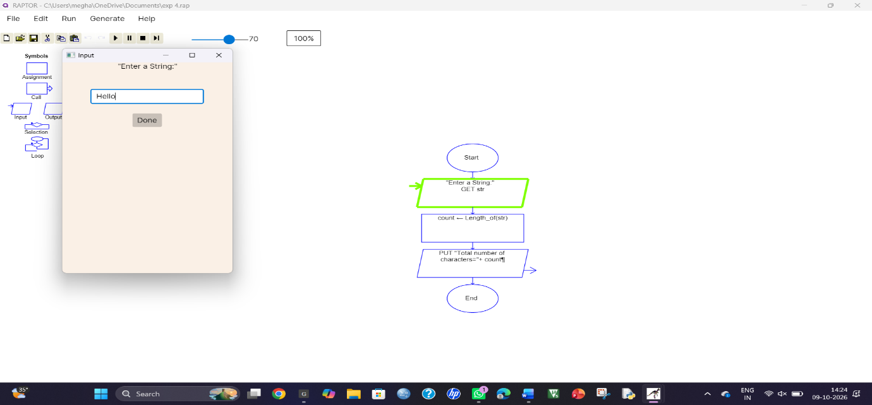
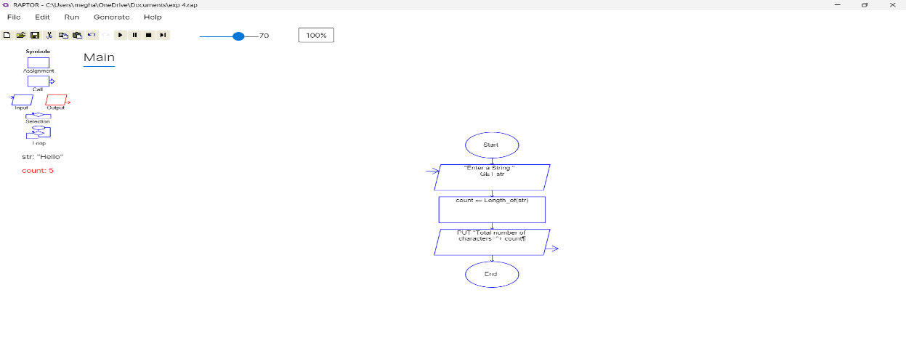
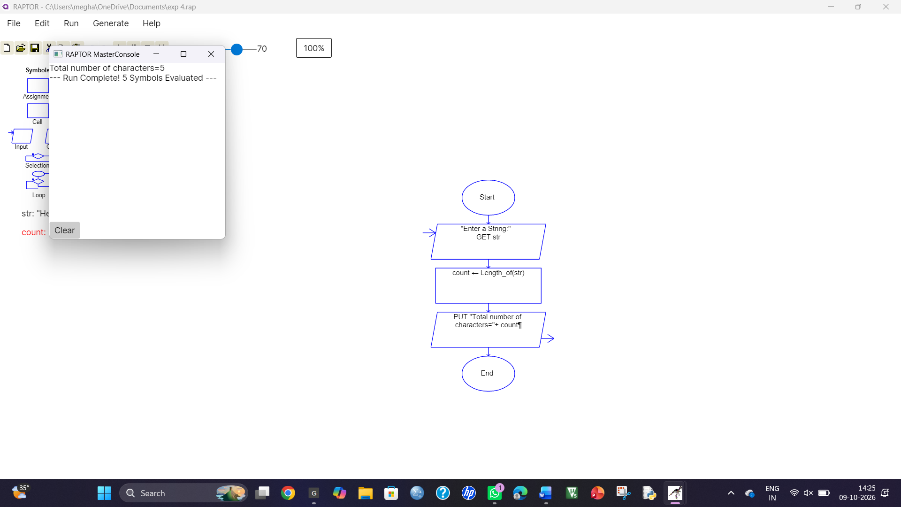

Result
Thus, the flowchart for displaying and returning the total number of characters in a string was created and validated successfully using Raptor.

